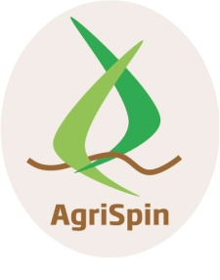



This project has received funding from the European Union’s Horizon 2020 research and innovation programme under grant agreement No 652642

**Cross Visit: Thessaly, Karditsa**

4-8 April, 2016

|  |  |
| --- | --- |
| **Moday** **4-4-2016** | Departure from Athens: 16.30  Arrival in Domotel Arni Hotel, Karditsa |
| DAY 1  **Tuesday 5-4-2016** | 9.15: From the hotel to ANKA S.A. offices (10 minutes by foot)  9.30-10.00: Refreshing the Methodology  10.00-11.00: Presentation of the Greek context  **Case 1: Agricultural Stevia Cooperative (ASYST)**  11.00: Bus from AN.KA. to Fanari (ASYST premises**)**  12.30 Bus from ASYST premises to Fanari Town Hall  12.45 Lunch  13.45Presentations and discussion with innovators and the support service  Reflections, timeline of the case  17.00 Visit to Fanari village  20.00 Dinner at Keramario* |
| DAY 2  **Wednesday 6-4-20165** | 8.30: **Case 2: Energy Cooperative of Karditsa (ESEK)**  Bus to Agiopigi (ESEK premises)  10.00: Return to ANKA S.A. offices  Presentations and questions.  Reflections, timeline of the case  13.00 Lunch  14.00: **Case 3 Agricultural Cooperative of Pulses and Food Items**  **(PSYHANTHOS)**  Presentations and questions  Reflections, timeline of the case  20.00: Dinner* |
| DAY 3  **Thursday 7-4-2016** | **Case 4: Efkarpon -****Superfoods**  9.00: Bus from the hotel to Mataraga (Efkarpon premises**)**  10.30: Return to ANKA offices  Presentations and questions  13.00: Lunch  14. 00: Internal meeting  Reflection on the cases, preparation of the seminar  18.00: Social Program  20.00Dinner* |
| DAY 4  **Friday 8-4-2016**: | 9.10 : From the hotel to the Thessaly Prefecture premises (by foot)  9.30: Seminar with regional authorities and rural stockholders  12.30 Bus to Plastira Lake and Lampero  14.00: Lunch in Lampero**  Departure to Athens |
| * Dinner at visitors own expense  ** Lunch offered by host | |